Table of Contents:
click to jump to contents
How to Launch the National Student Clearinghouse Report 1
Download as an Excel File 6
Prepare Excel File for Data Validation 8
Validating the Data 12
Repair Data through Mapping Configurations 12
Repair Data Manually 13

How to Launch the National Student Clearinghouse Report

Follow these instructions to launch the National Student Clearinghouse Report.
- Enter “Launch / Schedule Integration” in the Workday search bar.

- In the pop-up window, enter “NSC Enrollments Outbound” in the Integration field. Leave all other fields as is.
Click “OK”.
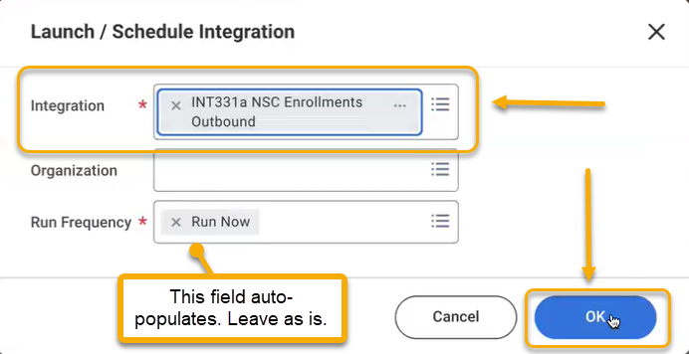
- On the Schedule an Integration screen, locate the Standard Academic Periods row. Enter the current academic period in the Value field. This report will only accept the current academic period.
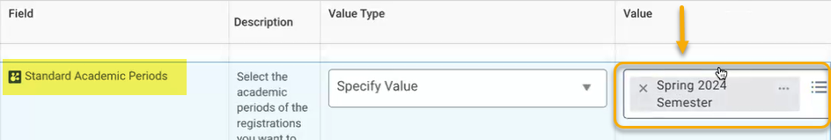
- Scroll down and locate the OPEID and Branch Code rows. Values are already built into the report. To select, click the value field and select the one available option.
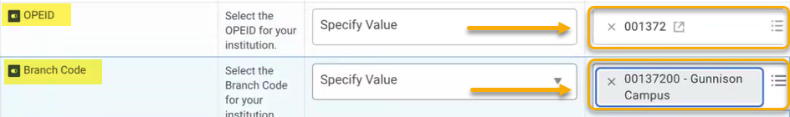
- Scroll down and locate the Last Enrollment Report Run Date.
To locate the date appropriate for this field, follow these steps. If you already have this date, skip to Step 11.
- Right click the browser tab and select “Duplicate”.
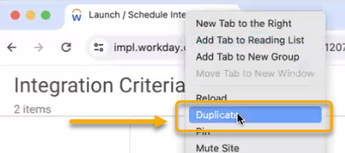
- In the new tab, search “View Integration Events” and click the Integration Events report.
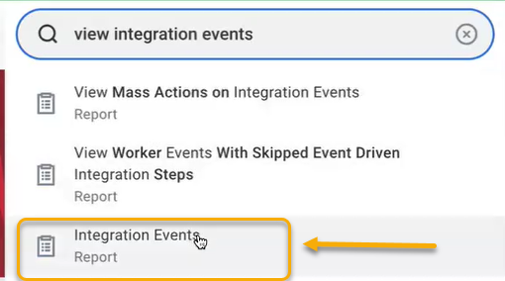
- On the Integration Events pop-up window, enter “NSC Enrollments”. Leave all other fields blank. Click “OK”.
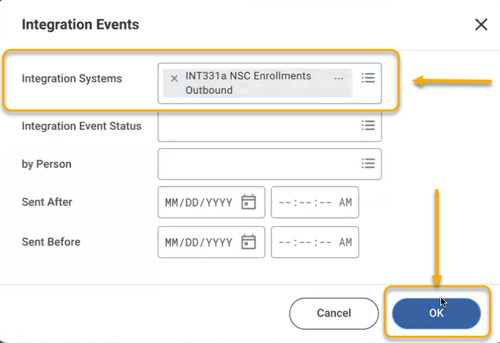
- A table outlining the previous instances of this event will appear. Scroll to the right to locate the Sent On column. Locate the most recent run date and note the date, hour, minute and seconds.
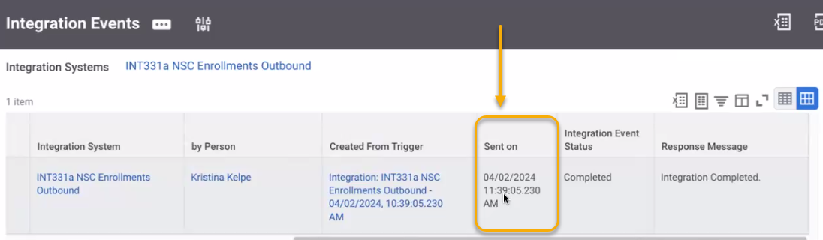
- Return to the original tab with the Schedule an Integration screen and locate the Last Enrollment Report Run Date row. In the field, enter the date and time as noted. The date and time are requested so that the report can track changes since the previous run.
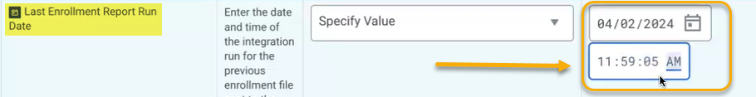

- Scroll down and locate the Override Academic Period Name row. The full academic period name is too long for the report. In the value field, enter a shorter alternative (up to 15 characters). In this example, we enter “SP24”.
- The following several rows should be auto-populated.

- When finished, click “OK”.

- The View Event screen will appear.
To refresh, click on the Integration Event link.
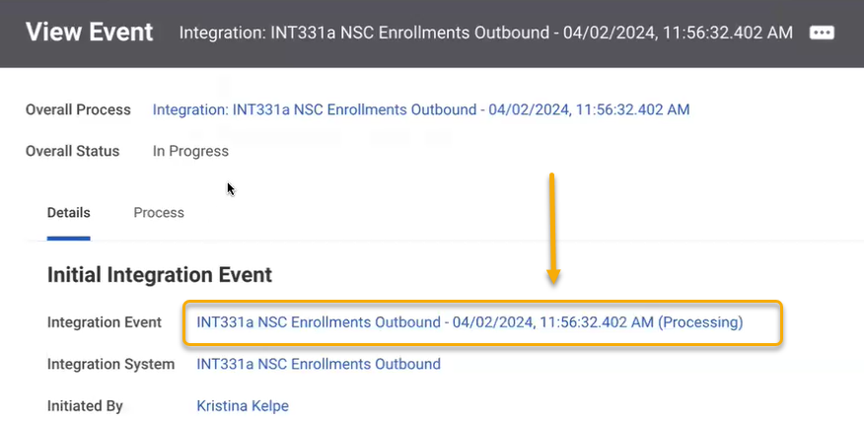
- Slowly, click the “Refresh” button repeatedly. Processing may take a few minutes.
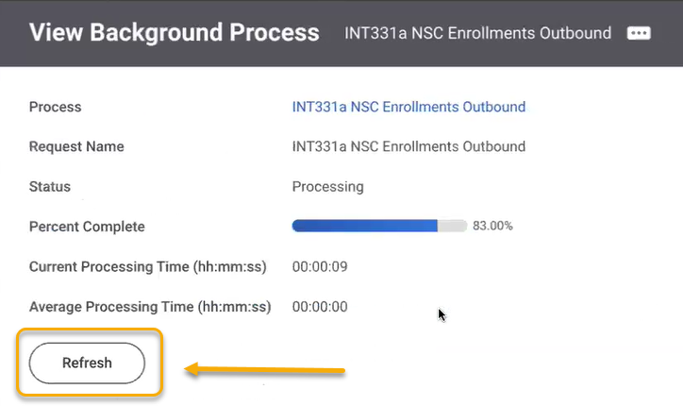
- Continue clicking until the report is complete.
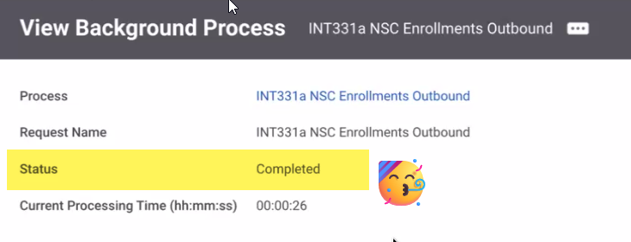

Download as an Excel File

- Next, click the Output Files tab.
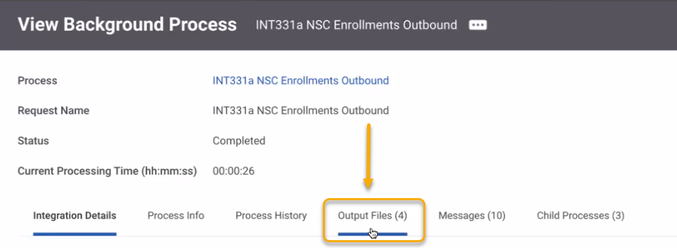
- Locate the .clr file. Do not select the .xls text file. It will not populate the data correctly.
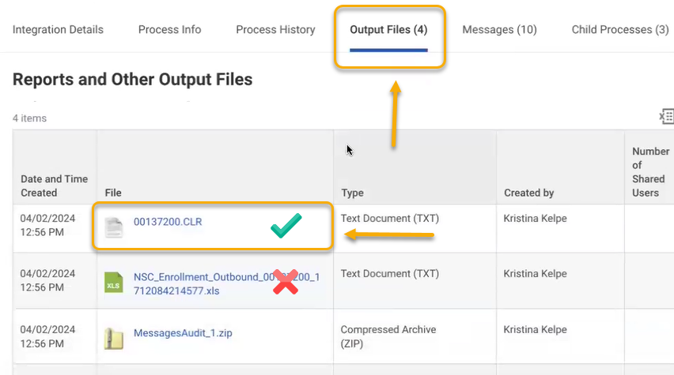
- Click to download the .clr file. Once downloaded successfully, open your downloads folder and change the file to .txt. This file extension change allows the file to be opened and read in Excel. Excel cannot read .clr files.

To change the file, follow these instructions.
Description | Screenshot
View the .clr file in the downloads folder | 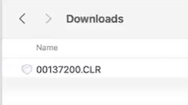
Highlight the .clr extension | 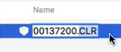
Delete the .clr and replace with .txt | 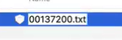
You may be asked to confirm the change | 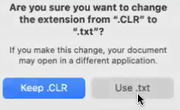

- To open the file in Excel, go to Excel and open a new file. Select the .txt file in your downloads folder.
Follow these instructions to navigate the configuration options prompted by Excel.
Instructions for Excel prompts | Screenshot (your screen may not look exactly like these)
Select “delimited”, then “Next”. | 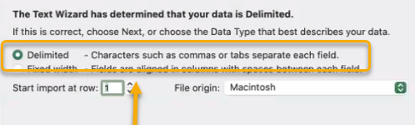
Select “Tab” in the Delimiters checkbox list, then “Next”. | 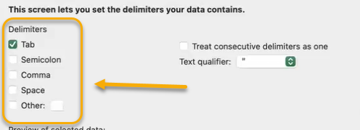
Select “Text” in the Column Data Format list. This is very important. If not selected, Excel will drop leading zeros from the data. | 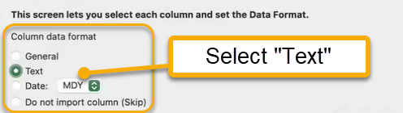
In the table, scroll to the right and select all columns and rows. | 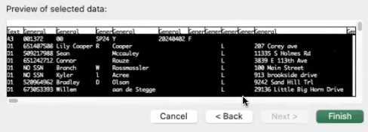

- Click “Finish”.

- Excel does not like holding onto the leading zeros and will ask you to convert the data and drop the zeros. DO NOT CONVERT. Click “Don’t Convert”.
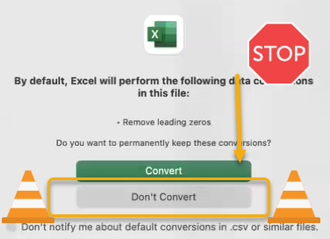

Prepare Excel File for Data Validation

You will always need to validate the data before submitting. This requires running separate reports out of Workday and doing comparisons with NSC output to make sure they match (e.g. the students reported as registered or with a status change).
- Save a copy of your report. I like to label it with the submission date and - Working Document.
- In Excel you can see the contents of your integration report. Notice, there are header and footer rows. The header does not contain column labels. So for validation purposes, you want to move those so that they don’t mess up your comparisons.
In order to add the column labels and properly review the data, continue through this guide and complete the following steps.
- Open a new tab in the sheet and label the new tab “Header-Footer”.
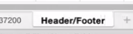
- Cut the header from the original tab and paste into the first row of the new Header-Footer tab.
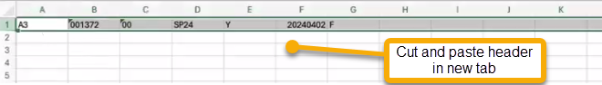
- Cut the footer from the original tab and paste into the third row of the new Header Footer tab.
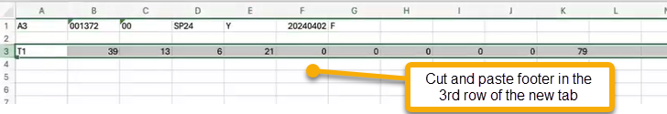
- Next, create a copy of the original worksheet tab. To do this, either right click the original tab and click “Copy” or right click either of the worksheet tabs, select “Insert Sheet”.
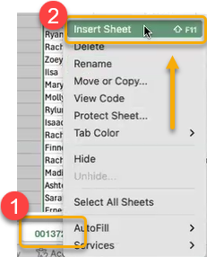
- Rename the new worksheet “Working Document”. It is important to carefully label your work to avoid confusion during this process. You should have something similar to this:
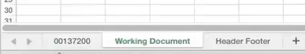
- At this point, you should have one excel file with three worksheets: 1) the original integration report without the original header and footer. The header and footer row should be empty; 2) a worksheet titled “Working Document” that is a copy of the original (without the header and footer). The header and footer row should be empty; 3) a worksheet titled “Header Footer” with only the original header and footer.

- Open the excel file provided by Beyond Academics: National Student Clearinghouse Enrollment Reporting File Headers.xls.
TIP: The information in this file was collected from the National Student Clearinghouse: Enrollment Reporting Programming and Testing Guide. This is a pdf available for download on their website. The document outlines the required header record layout. For your convenience, Beyond Academics makes this header record layout available to you in excel format.
There are three tabs in this file: 1) Read this first; 2) Header Row; 3) Detail Record Layout.
- View the Detail Record Layout tab. Highlight and copy the first row.
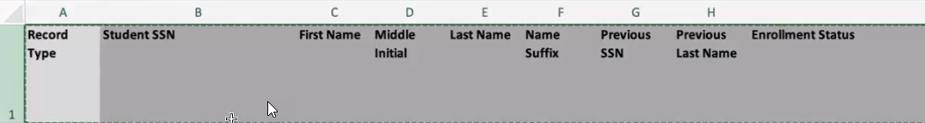
- Paste this header row into the first row on the Working Document tab in your integration report excel file. This first row should have been empty and you are now pasting this new header record into that row.
With this new header installed, your data should be labeled appropriately and much easier to understand and review.
- Scroll to the right and locate the College Student ID column. Highlight the column. Cut and paste in front of Column A. This is for your convenience and ease of use in preparing the data. Only do this in the Working Document tab.
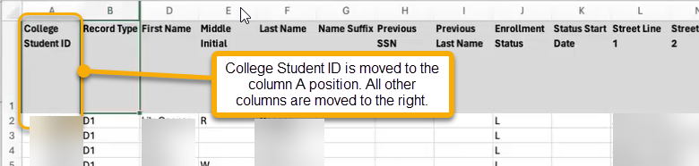
At this point, you should have your National Student Clearinghouse Enrollment data in the Working Document tab with the new header. This new header should align with the data. Here is an example:
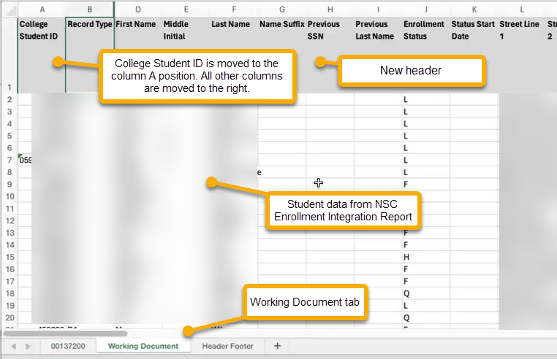

Validating the Data

Now is the time to review the data. Data validation is required when preparing the NSC report because data does not convert seamlessly between Workday and NSC, or even Banner and NSC. Workday is very exact with its data and in some cases offers more data fields than are permitted in the NSC reports. Consequently, the NSC report may simply drop the extra data fields provided by Workday. The misalignment between Workday and NSC tends to show up in predictable areas, or columns. Read the table below for more information on the columns that commonly present issues that need to be closely reviewed.
Review Header Item | Description
Street Line 1 and Street Line 2 | In some cases, Workday provides up to four street lines. NSC only allows for two resulting in dropped information.
Anticipated Graduation Date | This date is affected by the Workday configuration at your institution. Take a look at this to make sure your configurations are pulling data appropriate for the NSC report.
NCES CIP Code for Major; Major Course of Study | This data is pulled from Workday and the CIP codes must be in alignment.
First Time Full Time | This NSC field does not exist in Workday.
Race/Ethnicity | This field does not map well between Workday and NSC, particularly for international students or students with dual citizenship. You will likely need to manually make adjustments. See below for more info.
Program 1 Begin Date vs Program 1 Enrollment Status Effective Date | Although similar, these columns are distinct. Work closely with NSC and your report preparer to manage these dates. Any irregular date changes will be flagged by NSC and should be avoided. .

In addition to the highlights in the table above, review the Working Document worksheet carefully, looking for data that is missing or seems off. Make note of the categories that seem to present problems. This may be a problem in the mapping of Workday data to the NSC data. Mapping may not be completed or it needs revision.

Repair Data through Mapping Configurations

Data mapping in Workday is completed through the Configure Integration Maps for Integration System screen. Use this screen to ensure all configuration options are completed, or look for potential errors. See below for details.
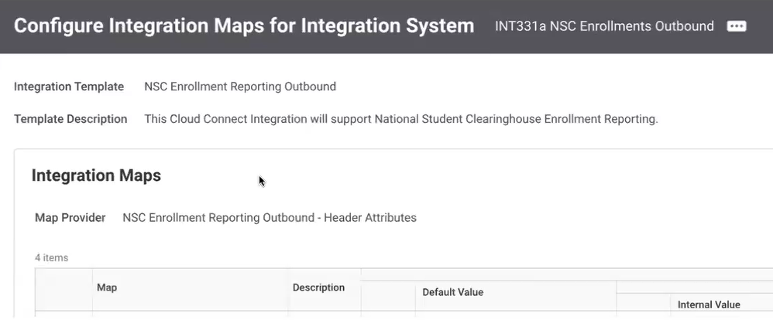

To navigate to this screen, enter “INTSYS: NSC Enrollment” in the search bar to locate NSC Enrollments Outbound.
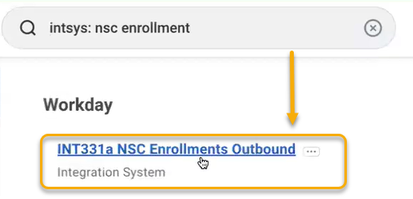
Click “Related Actions”, then “Integration System” and “Configure Integration Maps”. Ultimately, all the configuration options in this menu ought to be addressed.
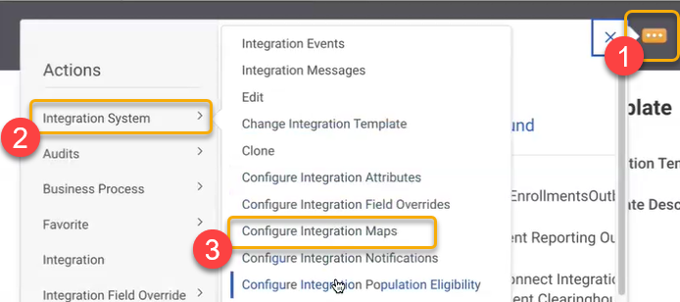

Repair Data Manually

Be aware that some data sets simply do not map well between Workday and NSC. The Race/Ethnicity field is an example. Students may have more than one value for this field. NSC will automatically prioritize one and drop the other. This, however, may lead to misleading reports. In preparing the NSC report, this field/column would need extra attention.
In this example, manual work is required by the report preparer. To remedy, the report preparer could run a Workday report on Race/Ethnicity. Then, using the Student IDs, match the Workday reported Race/Ethnicity to those students in the NSC Working Document worksheet using the VLookup function in excel. The preparer could then manually select or adjust to the correct ethnicity.
TIP: As you meet with NSC, clarify the data that is being reported and provide a sample. This way you can prepare only the required data, and do so consistently over time. The goal is to have consistency in your institution’s reporting over time, even through the Banner to Workday transition.

